

CAPSTONE PROJECT REPORT
Report 3 – Software Requirement Specification

– Hanoi, August 2019 –
Table of Contents
I. Project Report 3
1. Status Report 3
2. Team Involvements 3
3. Issues/Suggestions 3
II. Software Requirement Specification 4
1. Overall Description 4
1.1 Product Overview 4
1.2 Business Rules 5
2. User Requirements 6
2.1 System Actors 6
2.2 Use Cases 6
3. Functional Requirements 8
3.1 System Functional Overview 8
3.2 <<Feature Name 1>> 10
3.3 <<Feature Name 2>> 10
4. Non-Functional Requirements 11
4.1 External Interfaces 11
4.2 Quality Attributes 12
5. Other Requirements 14
5.1 Appendix1 - Messages List 14
5.2 Appendix2 - … 14
5.3 … 14

I. Record of Changes
Date | A, M, D * | In charge | Change Description
29/09/2026 | A | Tran Ngoc Khiet | Version 1.0  Add:  - 1. Product Overview  - 2.1 Actors
*A - Added M - Modified D - Deleted

II. Software Requirement Specification

1. Product Overview
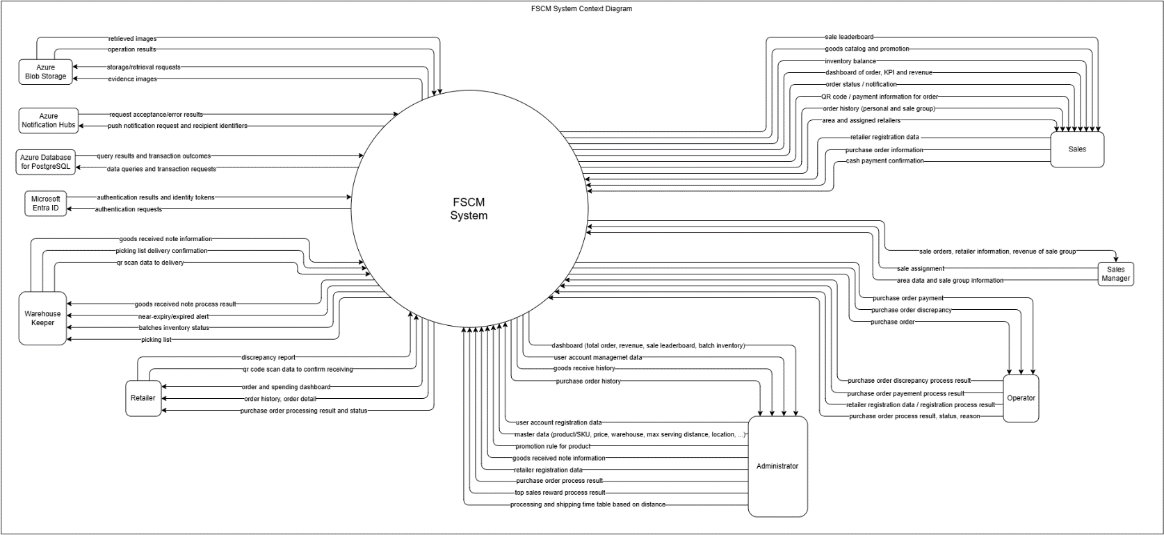
FSCM is a web and mobile-based distribution management platform designed to support the efficient distribution of perishable FMCG products from multiple warehouses to retail agents. The system provides core functionalities such as product and batch-level inventory management, purchase order processing, multi-warehouse inventory allocation, and order lifecycle tracking. Its primary users include sales representatives managing retailer orders, warehouse keepers handling inventory operations, retail agents monitoring their orders, and administrators managing system configurations. The platform aims to improve product allocation and reduce expiration-related waste by applying FEFO (First-Expired, First-Out) and MLOR (Minimum Life on Receipt) rules while considering inventory availability and service constraints across warehouses. The system also integrates with external and cloud services to support authentication, data storage, notifications, monitoring, and other operational functionalities.
Figure 1. FSCM System Context diagram

2. User Requirements

2.1 Actors
# | Actor | Description
1 | Administrator | Manages user accounts, roles, system configurations, master data, and overall system access and operations
2 | Operator | Manages operational data and configurations, including products, promotions, retailers, regions, and sales-related information
3 | Sales Manager | Manages Sales teams and assigned retailers, monitors sales performance, and reviews revenue and ranking information
4 | Sales | Creates and manages retailer orders online or offline, views product and inventory information, tracks order status, and monitors personal sales performance
5 | Warehouse Keeper | Manages warehouse inventory operations, processes stock-in activities, handles picking lists, scans QR codes, and prepares allocated batches for orders
6 | Retailer | Views order information and confirms the receipt of goods by scanning the provided QR code

2.2 Use Cases

2.2.1 Diagram(s)
[Provide the UC diagram(s) to show the actor-UCs and UC-UC relationships like the sample below. You can have multiple UC diagrams for the system]
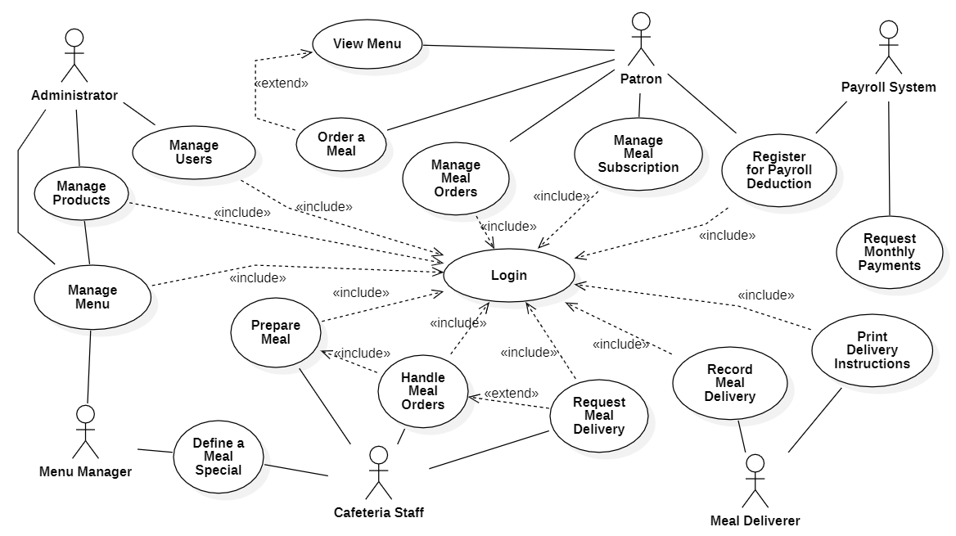

2.2.2 Descriptions
This part describes the use cases, you can follow the table form as below]
ID | Use Case | Actors | Use Case Description
01 | View Menu | Patron
02 | Order a Meal | Patron
03 | …

3. Functional Requirements

3.1 System Functional Overview
[Provide functionality overview of software system: screen flow, screen descriptions, system user roles, screen authorization, non-screen functions, ERD]

3.1.1 Screens Flow
[This part shows the system screens and the relationship among screens. You can draw the Screens Flow for the system in the form of diagram as below. Please note that beside the normal flat screen, we might have the oval notation for pop-up screen (Import Order) or a screen with multiple information tab (Order Details), etc. You may also use text or background format for different visuality purpose]
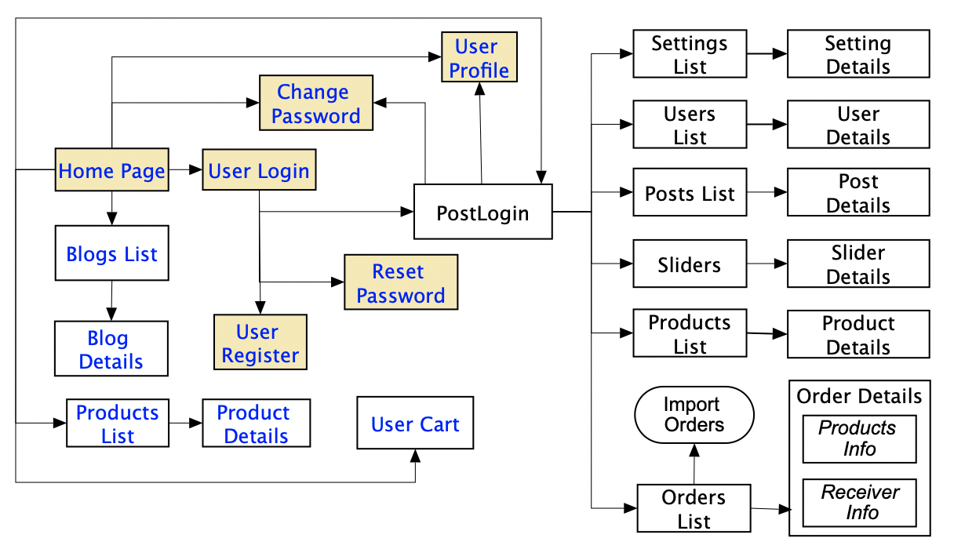

3.1.2 Screen Descriptions
[Provide the descriptions for the screens in the Screens Flow above]
# | Feature | Screen | Description
1 | Order Meals | Create Order | <<Screen Brief description>>
2 | Order Meals | Change Order
3 | ..

3.1.3 Screen Authorization
[Provide the system roles authorization to the system features (down to screens, and event to the screen activities if applicable) in the table form as below – replace Role1, Role2,… with your specific system user role names]
Screen | Role-Name1 | Role-Name2 | Role-Name3 | …
<<Screen Name1>> | X |  | X | X
<<Screen Activity>> |  |  | X | X
<<Screen Name2>> | X |  | X
Query All Data | X
Query Own Data |  |  | X
Query Managed Data |  |  | X
Add New Data |  |  | X | X
Update All Data |  |  |  | X
Update Own Data |  |  |  | X
Update Managed Data |  |  |  | X
Delete Data
…

3.1.4 Non-Screen Functions
[Provide the descriptions for the non-screen system functions, i.e batch/cron job, service, API, etc.]
# | Feature | System Function | Description
1 | <<Feature Name>> | <<Function Name1>> | <<Function Name1 Description>>
2 | …

3.1.5 Entity Relationship Diagram
[Provide the entity relationship diagram and the entity descriptions in the table format as below]
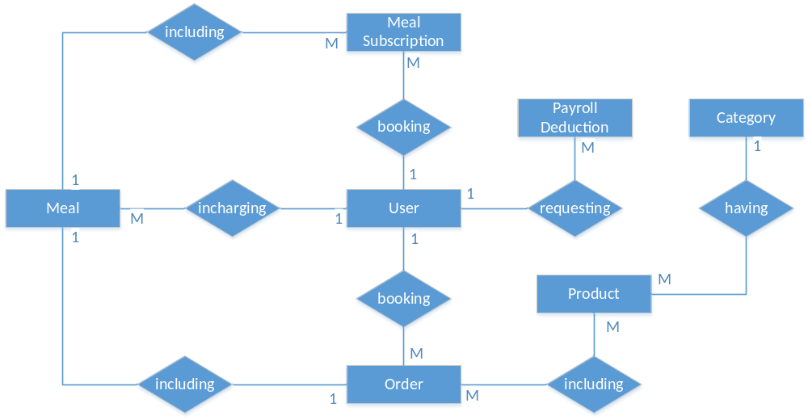
Entities Description
# | Entity | Description
1 | User
2 | Meal
3 | Meal Subscription
4 | …

3.2 <<Feature Name 1>>

3.2.1 <<Function Name 1>>
[A function can be a screen or a non-screen function (listed in the part 3.1.5 above). In this part, you need to provide the details on the related function, focus on mentioning below information
- Function trigger: how this function is triggered (navigation path, a timing frequency, etc.
- Function description: actors/roles, purpose, interface, data processing, etc.
- Screen layout: mock-up prototype of the screen, sample below is for Manage Products screen
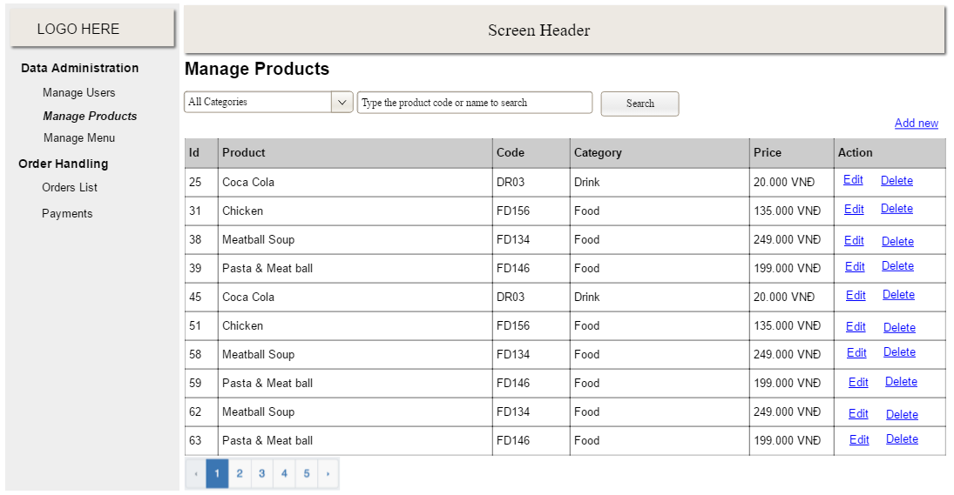
- Function Details: provide explanation for the data, validation, business rules, functionalities (for both normal cases and abnormal cases), etc. of the function so that the reader can image how it work.
]

3.2.2 <<Function Name 2>>
…

3.3 <<Feature Name 2>>
…

4. Non-Functional Requirements

4.1 External Interfaces
[This section provides information to ensure that the system will communicate properly with users and with external hardware or software/system elements.]

4.2 Quality Attributes
[List all the required system characteristics (quality attributes) specification. Some of the possible attributes are provided with the guide/descriptions are mentioned here]

4.2.1 Usability
[This section includes all those requirements that affect usability. For example, specify the required training time for a normal users and a power user to become productive at particular operations specify measurable task times for typical tasks or base the new system’s usability requirements on other systems that the users know and like specify requirement to conform to common usability standards, such as IBM’s CUA standards Microsoft’s GUI standards]

4.2.2 Reliability
[Requirements for reliability of the system should be specified here. Some suggestions follow:
Availability—specify the percentage of time available ( xx.xx%), hours of use, maintenance access, degraded mode operations, and so on.
Mean Time Between Failures (MTBF) — this is usually specified in hours, but it could also be specified in terms of days, months or years.
Mean Time To Repair (MTTR)—how long is the system allowed to be out of operation after it has failed?
Accuracy—specifies precision (resolution) and accuracy (by some known standard) that is required in the system’s output.
Maximum Bugs or Defect Rate—usually expressed in terms of bugs per thousand lines of code (bugs/KLOC) or bugs per function-point( bugs/function-point).
Bugs or Defect Rate—categorized in terms of minor, significant, and critical bugs: the requirement(s) must define what is meant by a “critical” bug; for example, complete loss of data or a complete inability to use certain parts of the system’s functionality.]

4.2.3 Performance
[The system’s performance characteristics are outlined in this section. Include specific response times. Where applicable, reference related Use Cases by name.
Response time for a transaction (average, maximum)
Throughput, for example, transactions per second
Capacity, for example, the number of customers or transactions the system can accommodate
Resource utilization, such as memory, disk, communications, and so forth.]

4.2.4 …

5. Requirement Appendix
[Provide business rules, common requirements, or other extra requirements information here]

5.1 Business Rules
[Provide common business rules that you must follow. The information can be provided in the table format as the sample below]
ID | Rule Definition
BR-01 | Delivery time windows are 15 minutes, beginning on each quarter hour.
BR-02 | Deliveries must be completed between 10:00 A.M. and 2:00 P.M. local time, inclusive.
BR-03 | All meals in a single order must be delivered to the same location.
BR-04 | All meals in a single order must be paid for by using the same payment method.
BR-11 | If an order is to be delivered, the patron must pay by payroll deduction.
BR-12 | Order price is calculated as the sum of each food item price times the quantity of that food item ordered, plus applicable sales tax, plus a delivery charge if a meal is delivered outside the free delivery zone.
BR-24 | Only cafeteria employees who are designated as Menu Managers by the Cafeteria Manager can create, modify, or delete cafeteria menus.
BR-33 | Network transmissions that involve financial information or personally identifiable information require 256-bit encryption.
BR-86 | Only regular employees can register for payroll deduction for any company purchase.
BR-88 | An employee can register for payroll deduction payment of cafeteria meals if no more than 40 percent of his gross pay is currently being deducted for other reasons.

5.2 Common Requirements
[Fill all the common requirements here..]

5.3 Application Messages List
# | Message code | Message Type | Context | Content
1 | MSG01 | In line | There is not any search result | No search results.
2 | MSG02 | In red, under the text box | Input-required fields are empty | The * field is required.
3 | MSG03 | Toast message | Updating asset(s) information successfully | Update asset(s) successfully.
4 | MSG04 | Toast message | Adding new asset successfully | Add asset successfully.
5 | MSG05 | Toast message | Confirming email of asset hand-over is sent successfully | A confirmation email has been sent to {email_address}.
6 | MSG06 | Toast message | Resetting asset information successfully | Return asset(s) successfully.
7 | MSG07 | Toast message | Deleting asset information successfully | Delete asset(s) successfully.
8 | MSG08 | In red, under the text box | Input value length > max length | Exceed max length of {max_length}.
9 | MSG09 | In line | Username or password is not correct when clicking sign-in | Incorrrect user name or password. Please check again.

5.4 Other Requirements…

